***Fusion of Art and Education***

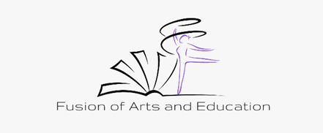

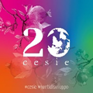   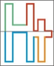

The European Commission support for the production of this publication does not constitute an endorsement of the contents which reflects the views only of the authors, and the Commission cannot be held responsible for any use which may be made of the information contained therein.

|  |
| --- |
|  |

Art and (political) adult education in Germany

A contribution in the framework of the Erasmus+ project FAE

Fusion of Art and Education

Aspects of the cooperation between art and education 2

Background and benefits 2

Funding 4

Projects 6

Contributions to the development of a strong participatory democracy and society 9

Arts and Science 12

Art and education at HochVier 13

HochVier e. V. Sarah Austrup August 2021

## Aspects of the collaboration between art and education

## The next pages will focus on aspects of cooperation between art and education in Germany. As a start, it can be said that there is already a great variety of cooperating artists and educational institutions. This cooperation takes place in great variety with different forms and under different conditions all over Germany. It can also be said that structures in the form of funding programs already exist nationally and also within the federal states (Bundeszentrale für politische Bildung 2019). One focus is on the cooperation of artists as extracurricular partners with schools. (Fischer and Hübner). However, the incorporation of artistic means and the cooperation with artists is not only practiced in the educational field of schools. In adult education, for example, the term "cultural adult education" is often used (Fleige et al.).

## The number of funding programs, cultural education institutions, publications, and individual projects that result from the collaboration of artists and educators in Germany varies widely at different levels. The following pages have the primary goal of describing the general status of the aforementioned aspects and to go into more detail about selected projects and programs. In addition to nationwide projects, a special focus will be placed on the developments and status in the state of Brandenburg and the local region around the city of Potsdam.

## Backgrounds and advantages

## There can be different reasons why artists decide to collaborate with educational institutions. On the one hand, such collaborations can serve to fulfil artists' own interests. For example, artists have the potential to reach a whole new clientele. Financial reasons can also be a reason for collaboration. Feedback from artists suggests that applying for funding can be particularly difficult. On the one hand, the wide range of funding and sponsors makes it difficult to recognize which funds are available at all. The application itself is also complicated, as is the subsequent accounting and proof of use. Here it is interesting, especially for the artists, to work together with educational institutions that can take over the application and accounting.

## In the cooperation, however, new spaces of experience can be created - for the artists and the learners. (Fischer).

## For educational institutions, too, there are several motivations for entering into collaboration with artists. Through aspects of art and with the help of artists, important social and political topics such as digitalization, migration and climate can be dealt with and communicated in a different way. Such and other topics require creative processes. Here, artists can contribute their specific potential and expertise. This also gives the organizations the chance to develop and professionalize themselves in terms of content and structure. (Fischer) Social, communicative and creative skills of the participants are also developed in such projects. (Fleige)

## Artists and educators have found in this kind of interprofessional collaboration that it is advantageous to establish basic principles and foundations for cooperation in advance. Both artists and people from the field of education have had different experiences with the cooperation. The experiences range from "very positive feedback to critical views and experiences of failure". It is important here, above all, for all those involved to have an open and curious attitude towards the new and unknown. Likewise, all partners must be willing to compromise and there must be respect and appreciation for each other's competencies. This approach is particularly important because it is quite possible that the different actors may view each other with prejudice. The different approaches that each side brings to the table must be seen here as an advantage for successful collaboration. (Fischer)

## While collaborations, for example, in civic education with artists do lead to positive results, it cannot be denied that problematic issues arise in such collaborations as well. For example, funding opportunities are often severely limited. In addition, it is not always easy to obtain the appropriate funding. Often, funders of political education projects that make use of artistic means in various forms get the impression that greater emphasis is placed on the cultural aspects rather than the political ones. There is an on-going discussion about how to adequately use artistic means to support political education aspects.

## It must also be mentioned that the cooperation between artists and educational institutions is often not of long duration. Here, financial backgrounds sometimes play a role. Other backgrounds are, for example, the (supposed/actual) restriction of artistic freedoms. In cooperation with educational institutions, there are often clear guidelines and requirements, especially in projects that are financed with subsidies. Here it can prove problematic if artists are expected to restrict themselves artistically and cannot use the full range of their creativity.

## 

## Funding

## Germany has a sophisticated system of funding for arts education.

## Fluctuations in the amount of funding can be seen in recent decades. While at the turn of the millennium there was a noticeable decline in funding measures, especially in the area of cultural adult education, there has been an upswing in funding and support again since 2007. This development was mainly influenced by the report "Culture in Germany" of the Enquete Commission in the German Bundestag (Fleige et al.). While the development of funding is basically positive, it can also be said that the funding landscape in cultural education is relatively confusing, especially since funding comes from different departments (culture, education and social affairs) and since all political levels from the federal government to the states and the municipalities are involved. (Fink et al. 2017) In the 2010s, there were further developments; from 2010 onwards, foundations in particular made their case for growth in the provision of cultural education through funding programs. Here, the focus is primarily on the area of extracurricular and school-based cultural education for children and young people. Cultural education should, among other things, support the area of inclusion in schools. (Fleige et al.)

## In Germany, the Basic Law stipulates that the promotion of art and culture is the responsibility of the states or the municipalities. Nevertheless, the federal government supports the field of art and culture, especially projects or cultural institutions that are of national importance. Here, 2 billion euros are invested annually, which amounts to about 17 per cent of total spending on art and culture. (Federal government) The states of Brandenburg, Hessen, North Rhine-Westphalia and Berlin have their own funding programs for cultural education.

## A special federal fund for cultural events is intended to give artists and the entire creative scene a new perspective after the pandemic. Up to 2.5 billion euros will be made available to support cultural events. In the state of Brandenburg, freelance cultural workers have also recently been supported with the so-called micro-scholarship program, among other things. A total of 4 million euros in the form of 1,000 scholarships with a value of 4,000 euros will be distributed to artists in the fields of visual arts, music, literature and performing arts. The program, which was first implemented in May 2020, is here mainly to support artists during the period of the COVID-19 pandemic. (Ministry of Science, Research and Culture 2021b)

## Funding for cultural projects in rural areas is also being sought. For example, in 2021, the Brandenburg Ministry of Culture decided to support specific cultural projects with duration of 3 years in rural areas. Such projects could include, for example, creative centres, digital hubs, or expanded Heimatstuben. Volunteer and civil society actors should also be involved here. (B.Z. 2021) Another funding program is also planned from fall 2021 with one million euros. This program is also intended to promote cultural development in rural areas, including through regional cultural anchor points. (Ministry of Science, Research and Culture 2021a).

## Cultural adult education is not explicitly mentioned in the laws of the federal states on educational leave (a paid leave of employees for professional, general, political or also cultural further education). Brandenburg is the only federal state in which this aspect is specifically mentioned. (Deutscher Kulturrat 2019)

## In workshops and educational institutions for people with disabilities or mental illness, much emphasis is placed on the inclusion of art and artists in specific educational work. There are a large number of projects and foundations here that promote this type of collaboration. (Werkstaetten-im-Netz 2021)

## Despite, or perhaps because of, a large number of offers of cultural education and the inclusion of artists, there is still a need for research and further training. For this reason, the Federal Ministry of Education and Research (BMBF) is funding 21 research projects that substantially address the question of how art and culture can be better designed and promoted in education. (Bundesministerium für Bildung und Forschung 2021)

Projects

The field of cultural adult education is already developed in Germany in a large variety. There are a large number of offers as well as a large number of sponsors. The approximately 900 adult education centres in Germany are publicly funded, as are museums, theatres and concert halls, for example, which are increasingly offering educational events. There is also the area of denominational adult education, such as Catholic adult education and Protestant adult education, but also Jewish adult education or Muslim adult education. Non-profit organizations as well as commercial providers are also active in adult education. (Fleige et al.). In addition to the field of cultural adult education, there is already a wide range of other arts and education collaboration projects in Germany. (Hunterman and Reichart 2014)

Adult education centres are the largest provider of adult education in Germany. About 15% of the total offer belongs to the subject area of culture and cultural education. But also beyond this area there are various collaborations of artists with people from other educational fields. The cooperation between the Hamburg Volkshochschule and the Thalia-Treffpunkt, the theatre pedagogical department of the Thalia Theater, shows what long-term cooperation between artists and educators in adult education centres can look like. Currently, the collaboration offers receptive courses, visual arts courses in workshops, and theatre projects and theatre camps. For example, the collaboration project "Looking behind the Scenes," planned for 2022, will focus primarily on the theme of identity. This will be brought together with the element of photography. Among other things, participants will learn to deal with light, backgrounds and objects (Fleige et al).

An example where art, specifically in this case music, meets political education is the project "Red October" funded by the Federal Agency for Civic Education. What role do art and culture play in turbulent times for politics and society? How do "political aesthetics" and "art politicization" work? The music of "Red October" is a combination of political education and cultural education dedicated to the "new" music of the Soviet Union of the 1920s, its artistic originality as well as its social development and political framework. In the six panels and concerts, musical experiences and political historical reflections are brought together in an innovative way. The added value of combining the two educational fields: Reflection does not remain abstract through the music listening experience, but rather receives immediate authenticity, and the aesthetic experience receives a new dimension of orientation in the historical visualization. (Work and Life)

Another interesting example is the theatre project "Rede mit mir - Boarding Europe" (Talk to me - Boarding Europe) from 2010, in which young ethnic German immigrants and young adults with a southern European background from the cities of Gelsenkirchen, Arnstadt and Görlitz participated. A young group of Turks and Hungarians also took part. The young adults were asked to bring their stories and ideas to the stage with the help of experienced directors. Here, above all, migration stories, stories of new experiences, of dealing with new people were told. With artistic means, the everyday life and reality of young people could be expressed. Thus, not only the audience of the theatre project could experience something new, but also the individual actors learned a lot about the different ways of life of their project partners - and about themselves. (Fleige et al.)

Another cooperative project is "Heimat, Deine Sterne" (Home, Your Stars). This intergenerational, film-based dialog project is aimed at people in different age groups in structurally weak rural areas in eastern Germany. The main aim of the project is to deal with the concept of "home". It also focuses on social, political and economic changes in rural areas. Through political education and the cultural area of "reflection documented on film", a better feeling for the concept of "home" could be developed and identity formation was also helped. (Fleige et al)

## Cultural adult education can also arise in connection with religion. The Catholic Church in particular attaches great importance to involving artists in its educational work. The Katholische Erwachsenbildung Deutschland - Bundesarbeitsgemeinschaft e.V. (Catholic Adult Education Germany - Federal Working Group). (KEB) sees the use of artistic means as a possible means of communication. Here, artists primarily serve as an interface of science, society and religion (Bregold 2018). "Art and cultural debate" are to take on a very specific and special role in adult education here. The Catholic Church refers here to a wide range of existing art resources. "Literature, music, architecture, visual and performing arts are ways of giving shape to thought and creatively approaching the mystery of creation," says Bishop Heinrich Mussinghof. The Church does not see itself here as an accidental actor, but rather as a great cultural carrier that wants to use art consciously and extensively in Catholic adult education. This orientation targets all senses and a world-centered orientation (Bregold 2018). The aspect of culture and art also plays an important role in Protestant adult education. How relevant this topic is reflected, among other things, by the number of participants in events with the thematic approach "shaping culture." In 2018, more than 550,000 took part in such events organized by the German Protestant Association. (DEAE) (Fleige et al.)

Contributions to the development of a strong participatory democracy and society

There are different ways in which collaboration between artists and visual artists can lead to a stronger participatory democracy and society. The artist Humphrey Maleka sees himself not only as an artist, but also as a political, stimulated person who wants to have a positive impact on society through his art. Professor Wolfgang Schneider has similar views "Art is not only beautiful, but can also have a social relevance." He says this is especially apparent in protest movements; artistic means such as posters, graffiti, song and theatre are used to give voice to political and social protest. (Harnitz)

The following examples show how a participatory society and the understanding of democracy can be promoted through collaboration between art and (political) visual artists. Thomas Baumgärtel ("The Banana Sprayer") works with the German non-profit association "Mehr Demokratie e.V." (More Democracy) to advocate for referendums in particular. Baumgärtel is especially known in the art scene for his sprayed bananas on about 4000 museums and art galleries. The artist has been working with the association "Mehr Demokratie e.V." for several years. In 2018, he campaigned for a more participatory society with the project "Ohne Volksabstimmung ist alles Banane".

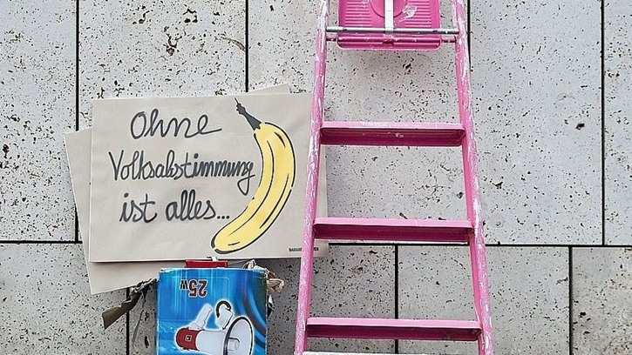

Baumgärtel's main aim with the campaign is to ensure that citizens have more say in important political decisions. Thus he says "I would like to have with important topics (e.g. with the withdrawal of the permission of Glyphosat) the possibility of being able to co-decide. Only every four years to make a cross is too little". The posters, which are mainly characterized by the large spray banana, were displayed in various relevant places, for example, in front of the German Bundestag or in the background of public press conferences.

Another project of the association "Mehr Demokratie e.V." was the democracy-art-action "Democracy for Future", here similar goals were aimed at as with the action "Ohne Volksabstimmung ist alles Banane". The action took place on 15.11.2019 in collaboration with the artist John Quigley in front of the Reichstag building. With the help of hundreds of people, a symbol of democracy recognizable from the air was created on the Reichstag lawn, a so-called aerial art sculpture. Quigley also wants to strengthen democratic society with his political-artistic action. In the interview he says "With my sculptures I want to inspire people to express their creativity. Each and every one of us has a responsibility to play a role in our society." Quigley wants to use collaboratively created art to act in the interest of the common good and enable a connection to important issues.

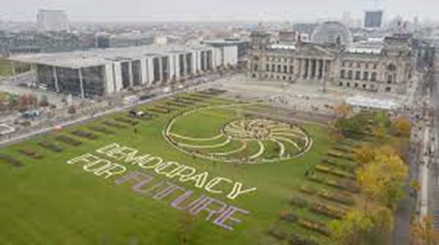

The artist Johannes Stüttgen also uses art and the idea of social sculpture (Beuys) to advocate for a more developed democracy. Similar to his previously mentioned colleagues, he trusts in the principle of direct democracy with referendums and decisions. For Stüttgen, direct democracy is above all elementary, since here everyone would have the right to co-determination. For this format he founded the "Omnibus gGmbH für Direkte Demokratie". Every year, an Omnibus tours Germany and occasionally parts of Europe to engage in discourse with citizens and encourage them to take on more political responsibility.

With her project "Everybody is a politician" the artist Anke Sondhof wants to create interfaces between people and art. Distributed throughout Germany in the years 2009 to 2013, the artist set up voting booths in which it is allowed to enter and which can also be described. Here, citizens* should be given the opportunity to express their opinion. Above all, this is to illustrate the process of personal decision-making. "Art is used as a medium to conduct a different form of debate about social responsibility," says Sondhof.

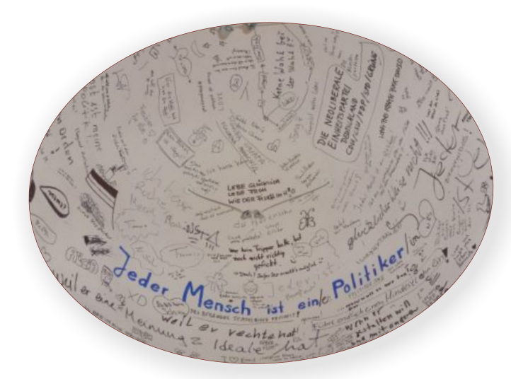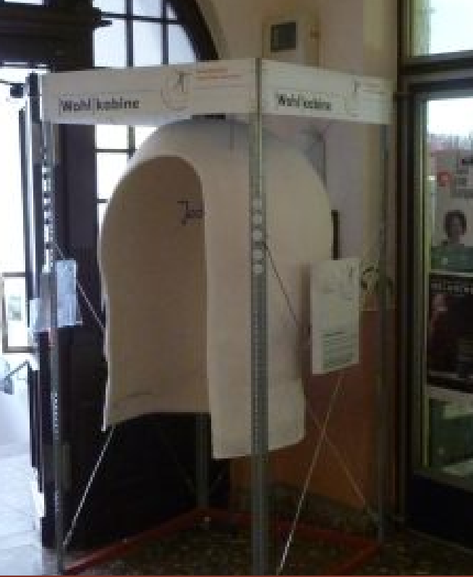

How to inspire citizens for a more pronounced participatory society in rural areas is also shown by the non-profit association "Landkunstleben e.V." was founded in 2001 in a small village in the Federal state of Brandenburg by artists, cultural workers, farmers and gardeners. The association has set itself the following goals, among others: to promote contemporary art, international exchange, care for the environment, culture of sustainability. In particular, social and cultural interfaces are to be created. Here, for example, a garden was worked on, which is to connect contemporary topics. With such projects, the association wants to create a participatory environment and involve people in art projects. Summer exhibitions and festivals are also organized for this purpose. Involved in the association's work are mainly local actors and associations from the community and the region.

# Arts and Science

# While in recent years, if not decades, there has been an increasing focus on science subjects in schools and universities, there are now mature approaches to including the arts in this field. One such approach is known as "From STEM to STEAM". The term STEM, comparable to the German term MINT, stands for science, technology, engineering and mathematics. In this area, more artistic means are now to be used to guarantee a more creative working process. The "A" in STEAM therefore stands for Art (Neue Wege des Lernes e.V. 2016).

# A number of German universities cooperate here, especially with the Rhode Island School of Design (RISD). RISD has launched an international project to promote closer collaboration between science faculties and artists and designers. (Braund and Reiss 2019). The inclusion of art, and especially artists, in science education will facilitate a better educational process that is informed by creativity and innovation. (Milgrom-Elcott 2019)

# In the project "Das Netzt- die Wildform ist Kosmopolit" in Potsdam, science meets art. Here, for example, physicists and climate researchers take part in performances in the Science Park in Potsdam in collaboration with actors and dancers. (Richter 2021) The project is primarily intended as an encounter between science, dance, media art and live composed music. Art is again used here as a means of communication, but this time in strong collaboration with science. (Leibniz Institute for Astrophysics Potsdam 2021)

Art and education at HochVier

HochVier e.V. as a non-profit association, which mainly focuses on extracurricular youth and adult education, uses a wide range of artistic means in the field of political education.

In the international project "Here they fought ", artistic photographs of places of remembrance and former battlefields are exhibited in order to create a better and more intensive culture of remembrance with regard to the Second World War and the acts and horrors that accompanied it. The (accompanying) use of images, which can be perceived more immediately and intuitively than other forms of communication, also takes place in other educational projects.

In the film project "SubTexte", a documentary film was made in cooperation with a group of students that deals with subculture and squatting in Potsdam. Here film is used as an artistic medium as a political (educational and discussion) contribution.

HochVier has been running play seminars for years on topics such as "conspiracy theories", "rent control", "financial policy" or "demographic change". Here, artistic and playful means are used to deal with complex, highly relevant topics.

This is also done in (political) theatre workshops in the tradition of Bertolt Brecht's learning play and Augusto Boal's "Theatre of the Oppressed".

HochVier has already gained experience in working with artists. These are now to be intensified and expanded.

In the future, HochVier could imagine such collaboration, for example, with the communication designer and photographer Simone Ahrend. Ahrend is on the board of the Walter Axthelm Foundation (WHA). The foundation, which is based in rural Brandenburg, focuses primarily on activating cultural and political self-activity and historical awareness in the town of Perleberg and the Prignitz region.

Artistic means are (also) used for this purpose. In projects on sustainability, for example, signets and card games were developed.

Photography also plays an important role. What can photography achieve politically and socially? These questions were addressed in several projects with refugees or young adults at upper secondary schools with photo training.

Photo work with young women and girls also helps to leave gender roles behind.

Literature list

B.Z. (2021): Drei Millionen Euro Fördergeld für kulturelle Projekte in Brandenburg, 19.07.2021. Online verfügbar unter https://www.bz-berlin.de/liveticker/drei-millionen-euro-foerdergeld-fuer-kulturelle-projekte-in-brandenburg, zuletzt geprüft am 21.07.2021.

Braund, Martin; Reiss, Michael J. (2019): The ‘Great Divide’: How the Arts Contribute to Science and Science Education. In: *Can. J. Sci. Math. Techn. Educ.* 19 (3), S. 219–236. DOI: 10.1007/s42330-019-00057-7.

Bregold, Ralph (2018): Kunst und Kultur in der katholischen Erwachsenenbildung. Deutscher Kulturrat. Online verfügbar unter https://www.kulturrat.de/themen/kulturelle-bildung/kulturelle-erwachsenenbildung/kunst-und-kultur-in-der-katholischen-erwa, zuletzt geprüft am 20.07.2021.

Bundesministerium für Bildung und Forschung: Metavorhaben zur Förderrichtlinie "Kulturelle Bildung in ländlichen Räumen" (MetaKlub). Online verfügbar unter https://www.empirische-bildungsforschung-bmbf.de/de/3126.php, zuletzt geprüft am 19.07.2021.

Bundesministerium für Bildung und Forschung (2021): Kulturelle Bildung in ländlichen Räumen. Online verfügbar unter https://www.empirische-bildungsforschung-bmbf.de/de/2976.php, zuletzt aktualisiert am 17.07.2021.

Bundeszentrale für politische Bildung (2019): Kulturelle Bildung: Fördermöglichkeiten. Online verfügbar unter https://www.bpb.de/partner/akquisos/292038/kulturelle-bildung-foerdermoeglichkeiten.

Deutscher Kulturrat (2019): Offensive für kulturelle Erwachsenenbildung. Positionspapier des Deutschen Kulturrates zur kulturellen Erwachsenenbildung. Online verfügbar unter https://www.kulturrat.de/positionen/offensive-fuer-kulturelle-erwachsenenbildung/, zuletzt geprüft am 20.07.2021.

Fink, Tobias; Götzky, Doreen; Renz, Thomas (2017): Kulturagenten als Kooperationsstifter? Förderprogramme der Kulturellen Bildung zwischen Schule und Kultur. Unter Mitarbeit von Wolfgang Schneider. Wiesbaden: Springer VS.

Fischer, Bianca; Hübner, Kerstin: Kulturelle Bildungskooperationen: Freiräume für Kinder und Jugendliche im Fokus. Eine Re􀀇exion individueller und systemischer Perspektiven auf die Zusammenarbeit von Kunst- und Kulturschaenden mit Schulen und Bildungseinrichtungen. Kulturelle Bildung Online. Online verfügbar unter https://www.kubi-online.de/artikel/kulturelle-bildungskooperationen-freiraeume-kinder-jugendliche-fokus, zuletzt geprüft am 20.07.2021.

Fleige, Marioan; Gassner; Julia; Schams, Mareike: Kulturelle Erwachsenenbildung. Bedeutung, Planung und Umsetzung: wbv Media GmbH & Co. KG.

Fleige Marioan; Gieske, Wiltrud (2020): Kulturelle Erwachsenenbildung als Ressource für Aneignung und Gestaltung ländlicher Räume. In: *forum erwachsenenbildung* 1. Online verfügbar unter https://www.waxmann.com/index.php?eID=download&id_artikel=ART103920&uid=frei, zuletzt geprüft am 21.07.2021.

Harnitz, Grete (2013): Kunst als Wegbereiter der Demokratie. In: *Die Deutsche Welle*, 19.03.2013. Online verfügbar unter https://www.dw.com/de/kunst-als-wegbereiter-der-demokratie/a-17099815, zuletzt geprüft am 18.07.2021.

Hunterman, H.; Reichart, E. (2014): Volkshochschulen (VHS) nach Programmbereichen und Fachgebieten. Bundeszentrale für politische Bildung. Online verfügbar unter https://www.bpb.de/nachschlagen/zahlen-und-fakten/soziale-situation-in-deutschland/61675/volkshochschulen-vhs.

Leibniz-Institut für Astrophysik Potsdam (2021): DAS NETZ- die wildform ist ein kosmopolit. Online verfügbar unter https://www.aip.de/de/calendar/958/, zuletzt geprüft am 19.09.2021.

Milgrom-Elcott, Talia (2019): When STEM Becomes STEAM, We Can Change The Game. Forbes. Online verfügbar unter https://www.forbes.com/sites/taliamilgromelcott/2019/11/07/when-stem-becomes-steam-we-can-change-the-game/?sh=176edf266905, zuletzt geprüft am 19.07.2021.

Ministerium für Wissenschaft, Forchung und Kultur (2021a): Land fördert kulturelle Ankerpunkte mit jährlich 1 Million Euro. Potsdam. Breiding, Stephan, Dortustraße 36, 14467 Potsdam. Online verfügbar unter https://mwfk.brandenburg.de/mwfk/de/service/pressemitteilungen/ansicht/~19-07-2021-kulturelle-ankerpunkte-1-mio-euro, zuletzt geprüft am 21.07.2021.

Ministerium für Wissenschaft, Forchung und Kultur (2021b): Land unterstützt freie Kulturschaffende mit 4 Millionen Euro. Potsdam. Breiding, Stephan, Dortustraße 36,14467 Potsdam. Online verfügbar unter https://mwfk.brandenburg.de/mwfk/de/service/pressemitteilungen/ansicht/~17-03-2021-mikrostipendien-iii, zuletzt geprüft am 21.07.2021.

Neue Wege des Lernes e.V. (2016): Von STEM zu STEAM - und was das bedeutet. Online verfügbar unter https://www.neue-wege-des-lernens.de/2016/10/25/von-stem-zu-steam-und-was-das-bedeutet/, zuletzt geprüft am 18.07.2021.

Richter, Mathias (2021): Spektakel unter dem Riesenfernrohr. In: *Märkische Allgemeine Zeitung*, 08.07.2021.

Werkstaetten-im-Netz (2021): Kunst und Behinderung. Online verfügbar unter https://www.werkstaetten-im-netz.de/rubrik.html?&r=2418&rubrik=Kunst%20und%20Behinderung, zuletzt geprüft am 19.07.2021.

